Currently working in the digital advertising landscape, I would like to focus my efforts on RoAS- Return on Ad Spend. There is not necessarily a prevalent issue I’m dealing with now, but there are some kinks in our programmatic online display advertising as far as not hitting certain key performance indicator benchmarks. To measure performance in advertising, the key metrics that are focused on are generally clicks, click through rate, conversions, conversion rate, and all-encompassing cost calculations surrounding them- For example, cost per conversion is equal to total media spend divided by total conversion count. We are currently running on several different platforms, but for the sake of this discussion I’ll focus on performance comparisons between two- Adwords, running on the Google Display Network (I’m leaving Google Search/Bing Search out of this discussion because those are lower funnel tactics aimed at finding consumers closer to the point of purchase), and Tradedesk, a demand side platform which runs on a more comprehensive list of publishers engrossing, basically, the entire internet. The solution seems simply at a base level – Why not consolidate ad spend into one platform? Well the answer to that is simply based on diversifying our offerings and finding consumers at different stages of the buying cycle. Different sites and targeting mechanisms (a lot of proprietary data usage), is available when working with The Trade Desk as opposed the GDN. The problem, as it currently stands, is the Cost per Action/Conversion being significantly lower on the GDN as opposed the running on The Trade Desk. I know I have a problem because the data is telling me that out of all the consideration/conversion vendors we run on, this is the lowest aggregate CPA. This is a problem that needs to be fixed because our performance is based on driving these conversions, which is essentially a click out from our site to a specific dealer site- For context, our site is a representation of regionalized groups of dealers who pool their money together. We act as a portal from the Tier 2 automotive level to the Tier 3 sites/dealers, which are actual dealerships- Getting someone from our site to any of the dealers’ sites is registered as a conversion. It’s our main KPI and can be associated loosely with lead generation. **Rev: Because of the complex nature of my problem, I will instead focus on a simpler solution- Decreasing my CPC, or Cost per Click. This will minimize the amount of variables at play and allow me sufficient enough data to make an actual**

**I will measure success by pointing to click through rate, rather than CPA. Logically, if I am driving more people to my sites, than I should be able to generate more click through conversions, even if my conversion rate remains stagnant. Cost per Click is a measure of total media spend/total. The result of that calculation will be my key output, or my Y. I want to be significantly better than I currently am- The programmatic efforts we run through Google generally result in a 0.30-0.50 CPC, while the other efforts register in the 1.50-2.00$ range. My goal is to drop my CPC to $1.00. The monetary value for enhancing my performance would be calculated by determining the cost that I am paying per click. If I am able to generate the same amount of clicks with half of the normal media spend, then we have 50% more spend to put back into driving more site traffic. To quantify this, we’ll use a placeholder budget of 5,000$. This may change depending on my Feb budgets. Example of value to business: I currently drive around 2500 clicks, or site hits, per 5000$. If I am able to cut the CPC from $2 down to $1, I can generate twice as many clicks. Assuming a linear relationship between total sessions and total conversions, I am helping to achieve my main goal. The X inputs, or the variables I will be testing, will range. I want to look at the relationship between 3 specific variables in relation to my Y, which is cost per click:**

**Ad format: this is defined by the size of the ad. I generally only run 320x50, 728x90 and 300x250 ad sizes.**

**Device type: This generally falls within Mobile/Tablet/PC/Other (Other is unidentifiable)**

**Fold: This is where the ad appears on a page, and is defined by either above/below/unknown**

**REV REV:**

**After speaking with the professor, it might be better for me to eliminate the use of purely categorical data, with which I might have to resort to some form of binary expansion, IE which campaign designs result in the highest corresponding results . Because this is purely a test of which X variables are driving the changes in my Y variable, I will pivot back to using a variation of my initial Y, but in a continuous manner, rather than a pure count. I will measure my CR (Conversion Rate: Clicks/Total Conversions) against a variety of variables. A conversion is an expansion of a click- It is an action that a user takes after initially clicking on an ad and being redirected to a new page. What I will look at is the relationship between my daily spend in sub variables of device type, and ad size. I will also include some other variables, such as which day of the week produced the highest conversion total, which hour of the day produced the highest conversion total/or which range of hours produced the highest total, did I have to make any changes to my daily budgets within a given day due to budget/pacing constraints, how many changes did I make, how ad groups do I have live during each day. These are variables that I don’t believe have a tremendous impact on my outcome, just based on some high-level analysis I’ve performed in the past, but this will assign an actual statistical relevance to what I have only inferenced in the past. What I hope to do through my actions and multivariate testing is have a direct impact on the overall conversion rates of the campaigns that I am currently running. I would deem any positive direction a success, but because there is a standard deviation present in the daily data, I will shoot for somewhere between a 10-20% increase in conversion rate, which I deem would make this experiment a success.**

**With this pivot comes a slightly different business impact, but something that falls under the same umbrella. Unable to attribute purchase data back to advertising efforts, as mentioned earlier, I will have to rely specifically on the ad dollars that are being saved, and that are/would be available if this DMAIC process were to render positive results. If my conversion rate increases by 10%, there is a direct impact on the cost per individual conversion that I spend. The impending impact would result in 10% more dollars to spend during any given month to pursue further leads- This equates to roughly 6,000$ per month.**

I think my boundaries, or some of my current limitations are correlated with the number of variables that are in play. There are so many different data points that can directly impact performance, and my hope is to be able to isolate the main drivers of performance, or to be able to weight them in a way to makes optimization more strategic, rather than just spraying and praying. There are certain latency times associated with certain data pulls, depending on how granular I go, so that is an additional boundary. Lastly, I might not have much budget to play around with during this assignment. I currently run all of operations happening at the programmatic level, so the results are directly indicative of the work I’m putting in. I think this helps because there are no extra measures being added in for human behavior, besides my own. Not many people at my company are data savvy, so this is a task I’m putting on my shoulders for the time being.

Define- The problem has been defined within the scope of my comprehension. This step is complete.

Measure- I currently have some baseline data, but would need 1-2 weeks to allow for a statistically significant data set- I can pull historical data to run tests on.

Analyze- 1-3 days to run correlation/regression + separate forms of ROI analysis.

Improve- Take my finding from the measurement stage and implement more budget into what I think will succeed- Ex, if mobile, 320x50, above the fold would drop CPC. This step will take about 1 week.

Control- An additional week to continue to monitor performance to see if y truly does equal f(x).

I have quite a few boundaries in play, so to simplify this I’m going to focus strictly on the performance that I can influence through a variety of testing, and multivariate analysis. There are still elements to advertising in certain verticals that are more speculative, rather than data driven. The hope is to define the variable and weight them based on influence, and finally determine which of them has the biggest impact on performance, or if multiple changes to the X’s would result in the greatest change in Y. This knowledge will allow me to achieve optimal performance levels, and is ultimately giving our clients the most value for the money that they are putting in. I might need to pick a few variables to allow myself a reasonable test. If I were to test too many, I could run into an issue where I’m not able to source back certain items.

Key of various metrics- Page 3

Flow Chart on Page 4- High level outlook of my issue, and the process to which I hope to find a solution.

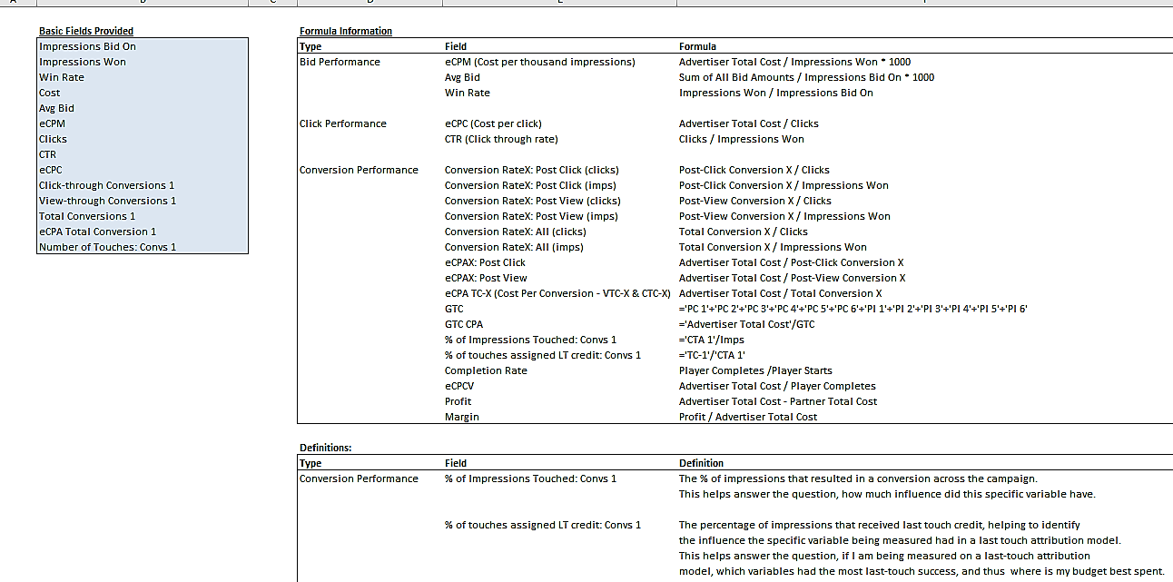

Document results

Identify Inputs/Variables

Improving Programmatic Performance as defined above. Success is measured by CPC. CPC = Media Spend/Clicks

Maximize RoAS

Control Results

Measure Results against goal

Test plan

Develop a plan

Correlate inputs w/ outputs

Define Goal

Weight Inputs

Brainstorm Solutions

VS

Tradedesk

GDN

Measure current Performance.

Define Problem.